1. sendOtp :-

API :- http://localhost:4000/api/v1/sendOtp

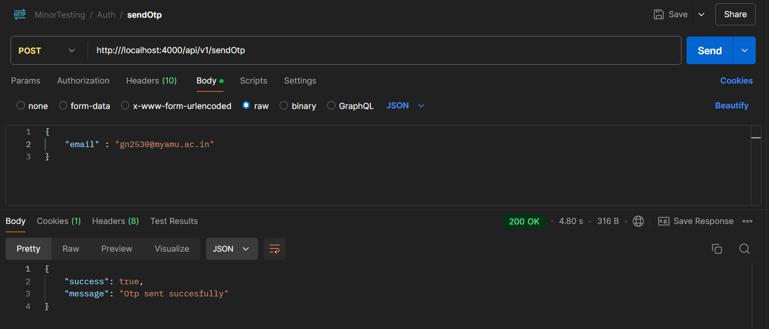

1. SignUp:-

API :- http://localhost:4000/api/v1/ signup

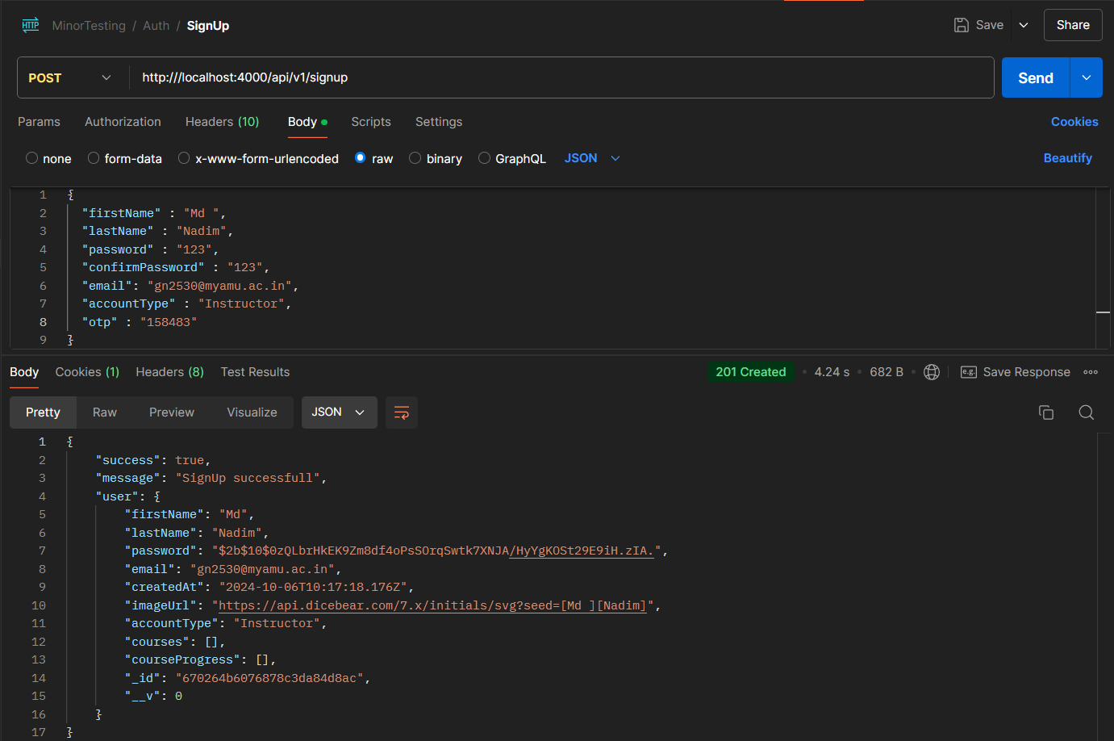

1. Login:-

API :- http://localhost:4000/api/v1/ login

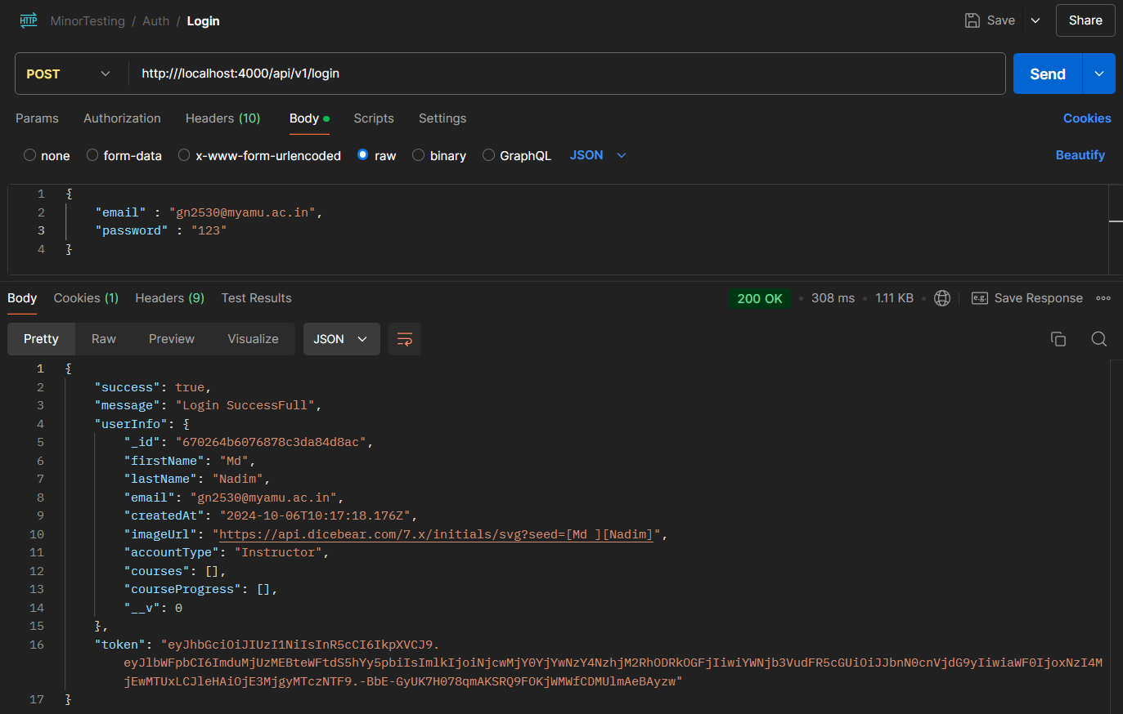

1. changePassword:-

API :- http://localhost:4000/api/v1/changePassword

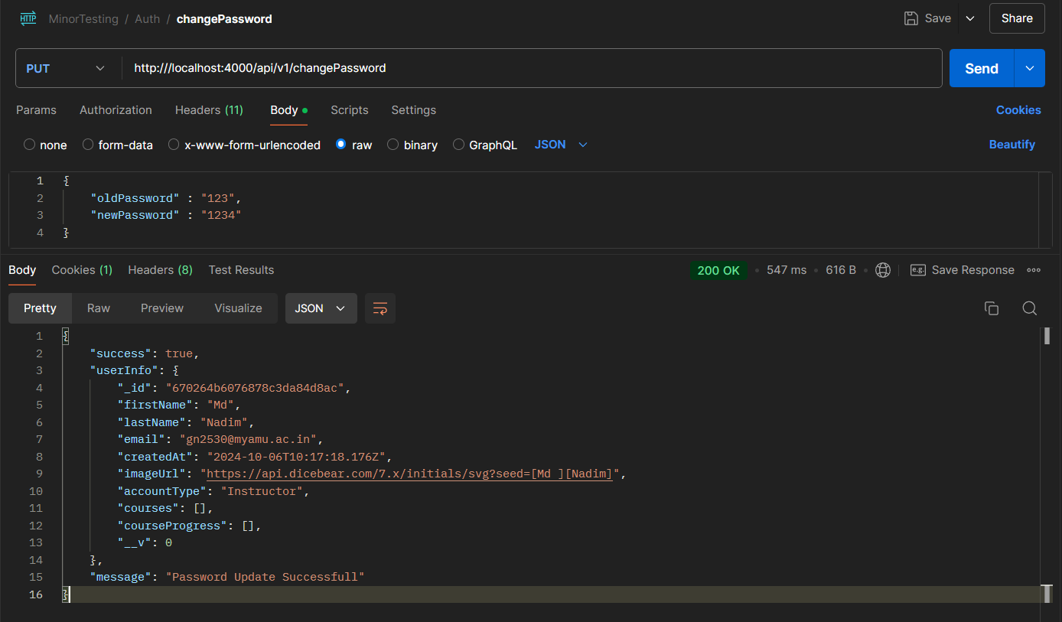

1. createTag :-

API :- http://localhost:4000/api/v1/createTag

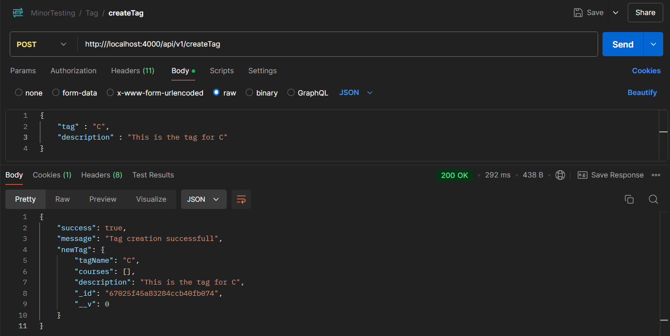

1. editTag :-

API :- http://localhost:4000/api/v1/editTag

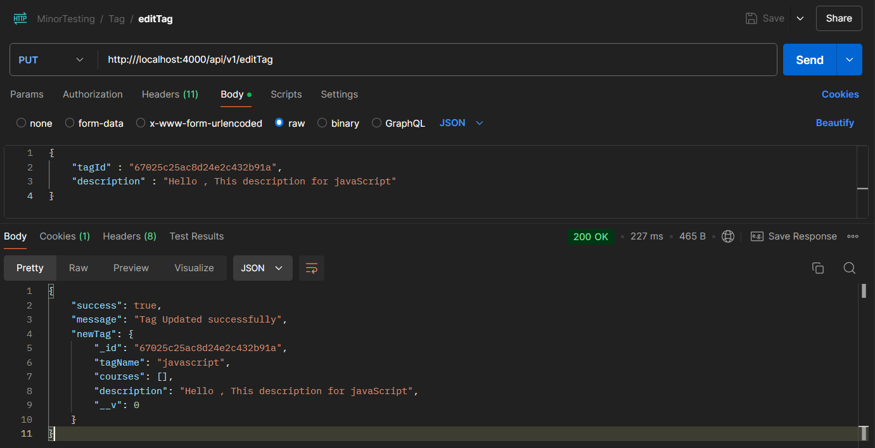

1. getAllTags:-

API :- http://localhost:4000/api/v1/getAllTags

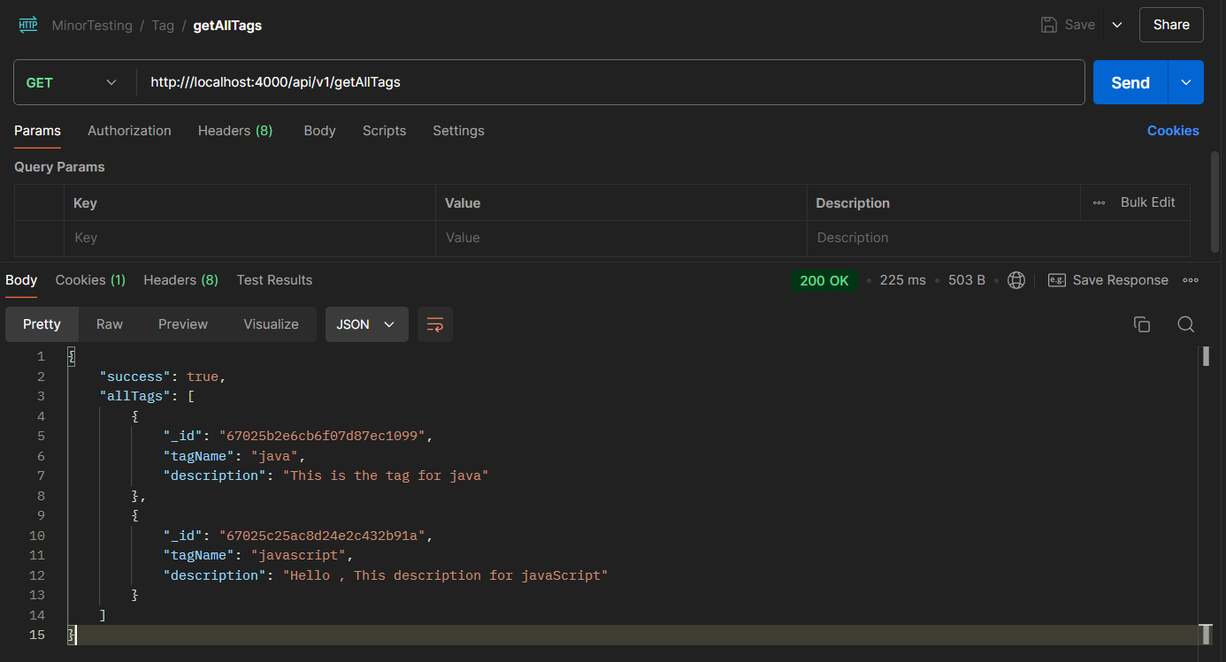

1. deleteTag :-

API :- http://localhost:4000/api/v1/deleteTag

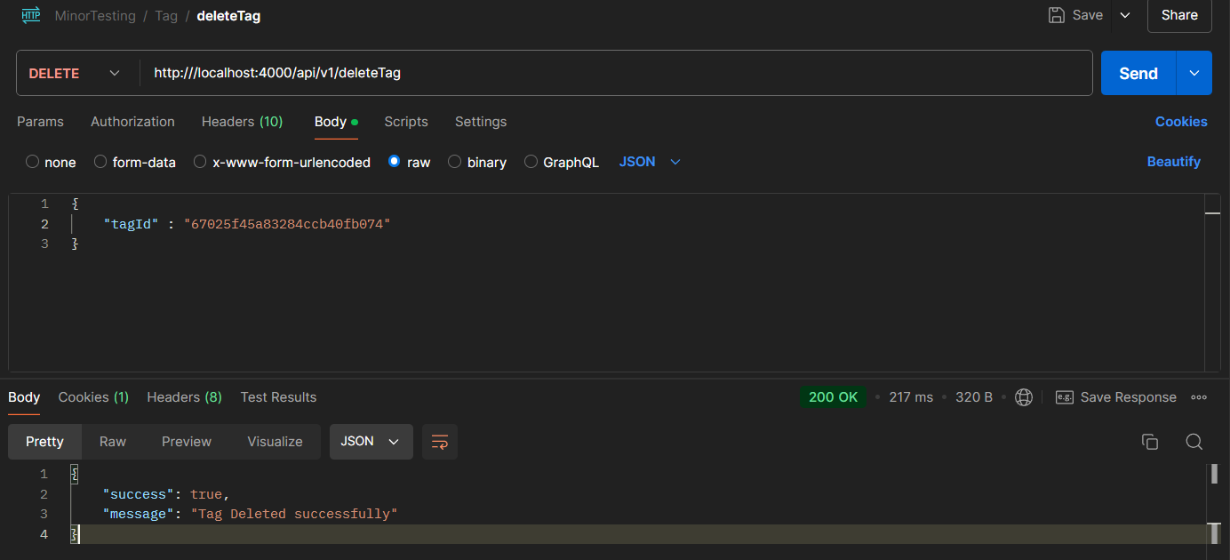

1. createCourse:-

API :- http://localhost:4000/api/v1/createCourse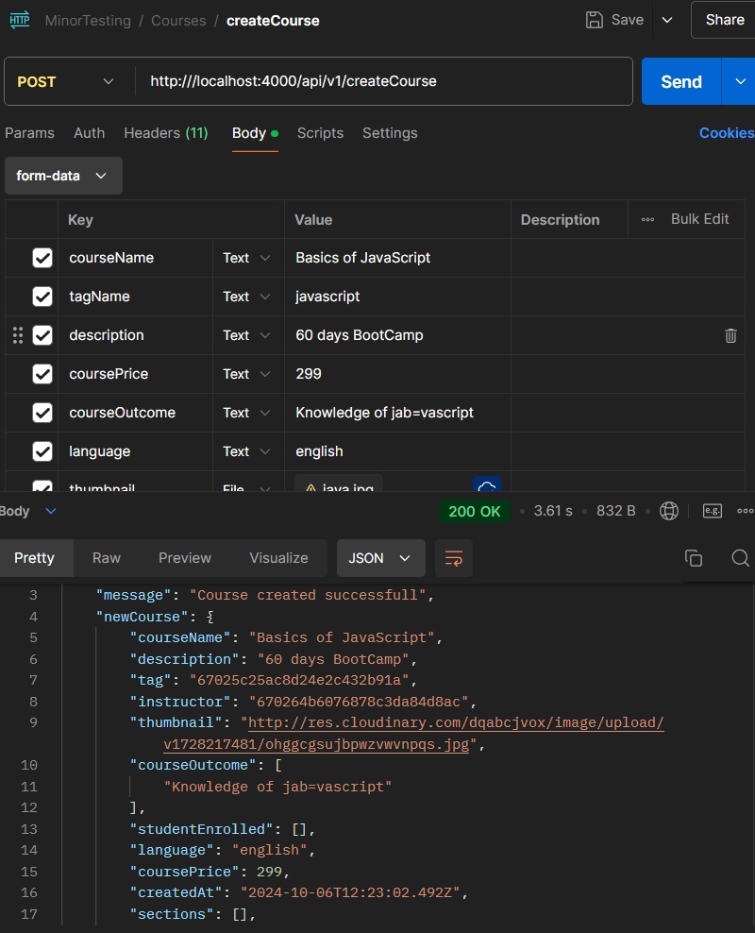

1. getAllCourse:-

API :- http://localhost:4000/api/v1/ getAllCourse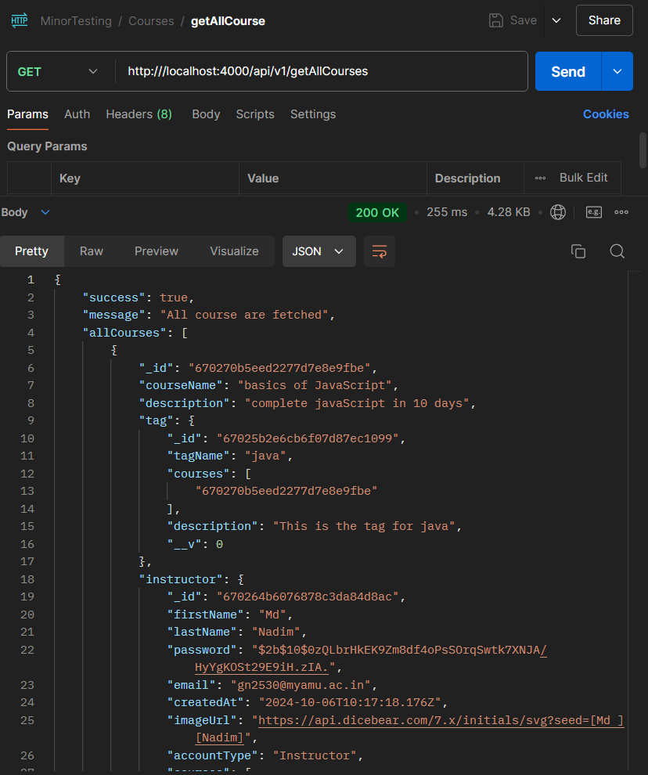

1. getCourseDetails:-

API :- http://localhost:4000/api/v1/getCourseDetails

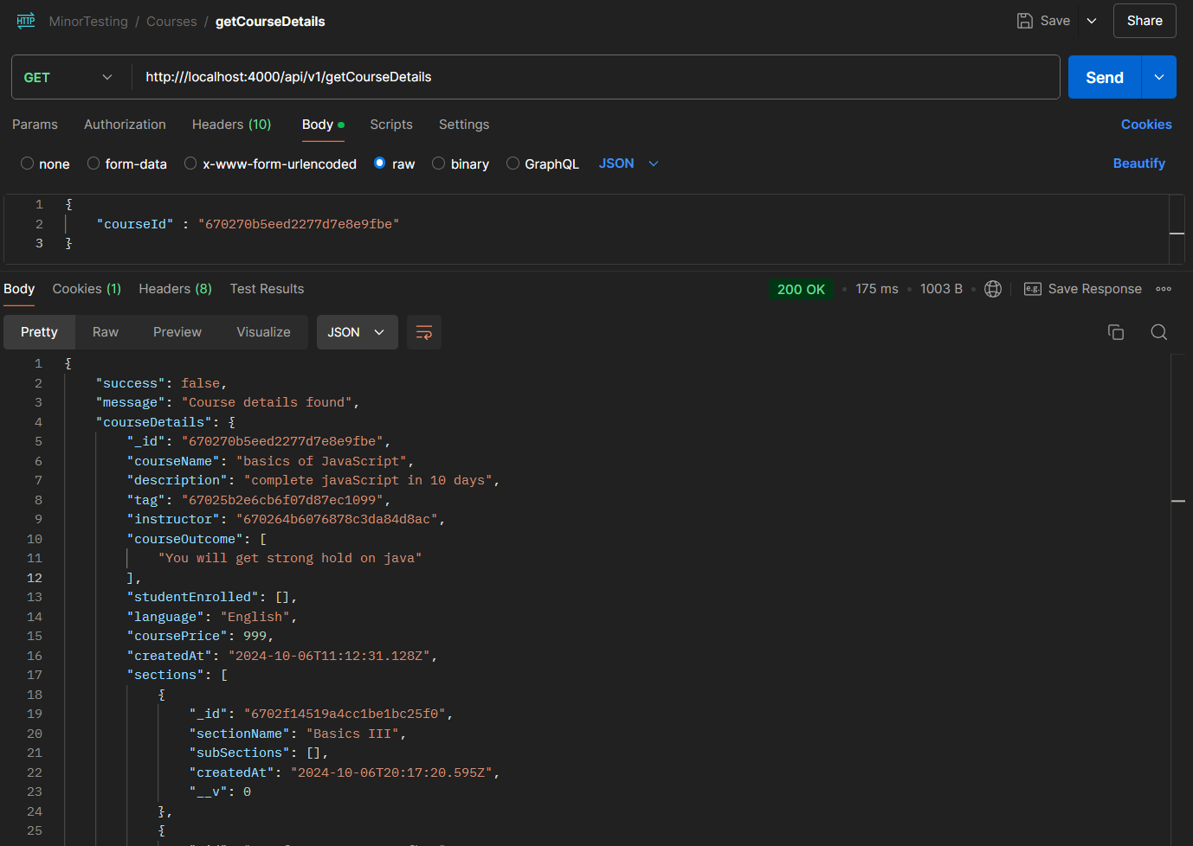

1. createFAQ:-

API :- http://localhost:4000/api/v1/createFAQ

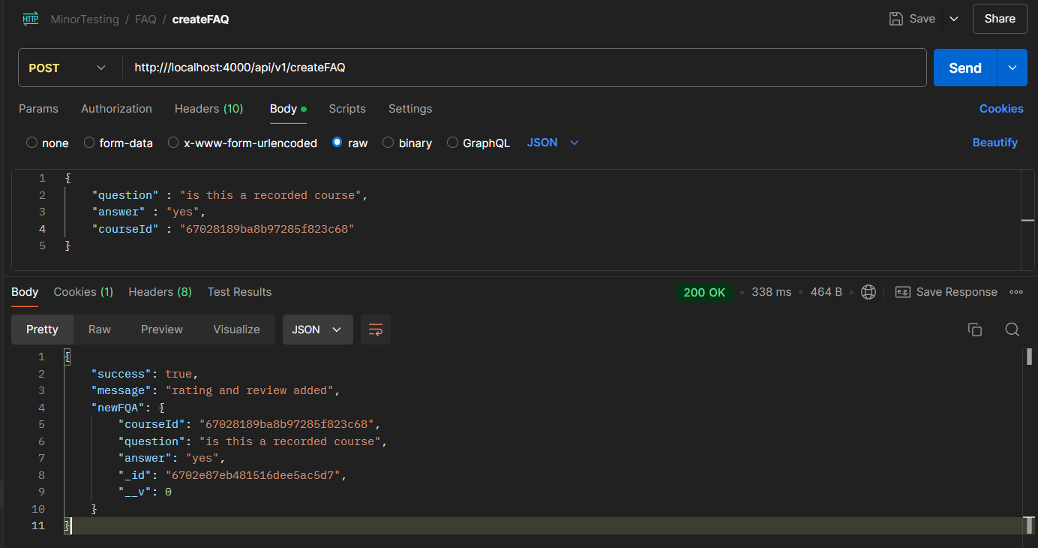

1. getAllFAQ:-

API :- http://localhost:4000/api/v1/getAllFAQ

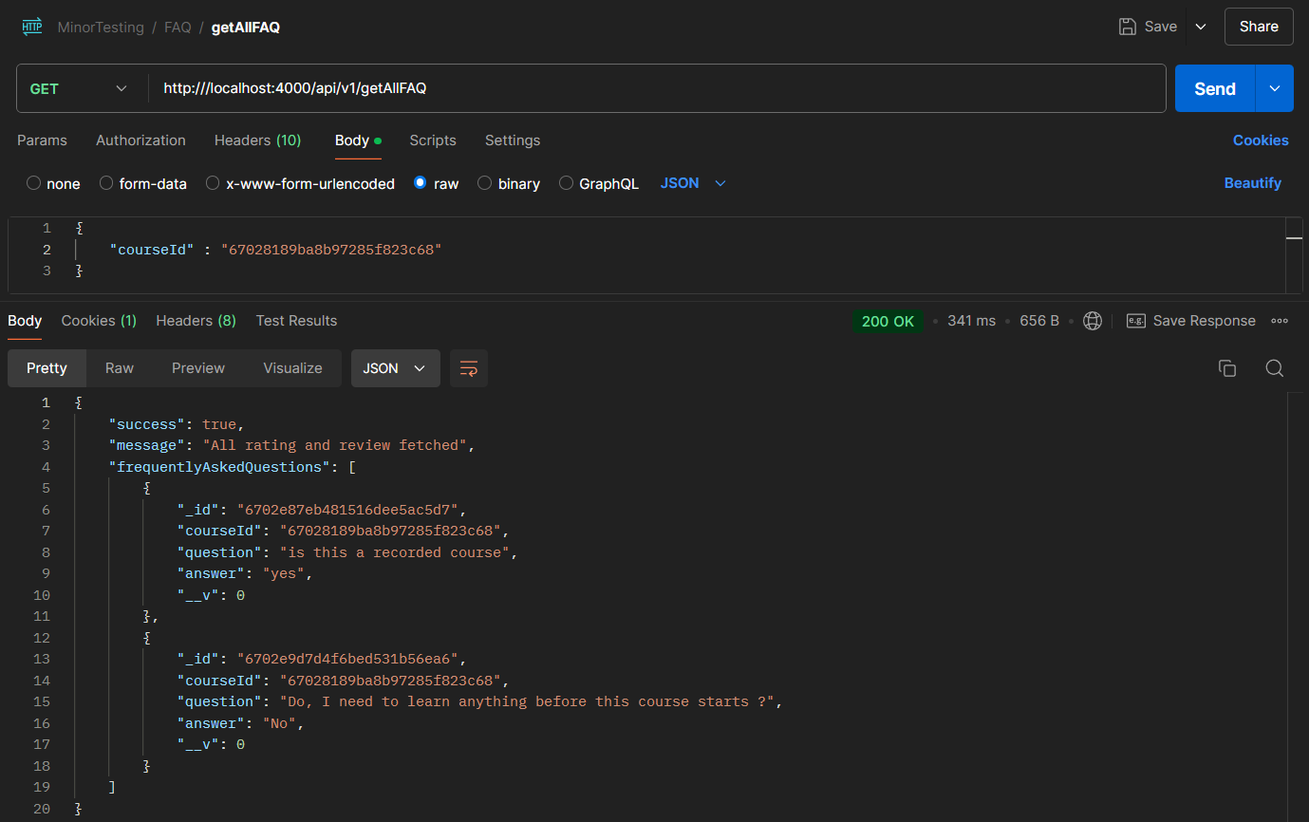

1. deleteFAQ:-

API :- http://localhost:4000/api/v1/deleteFAQ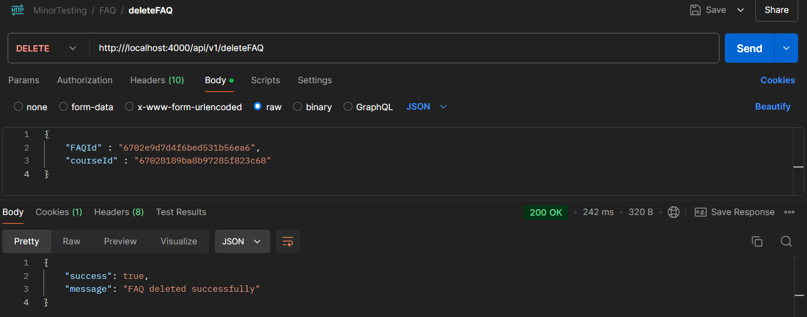

1. editFAQ:-

API :- http://localhost:4000/api/v1/editFAQ

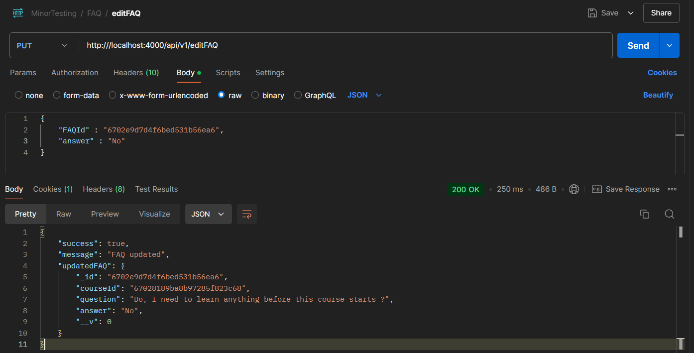

1. createSection:-

API :- http://localhost:4000/api/v1/createSection

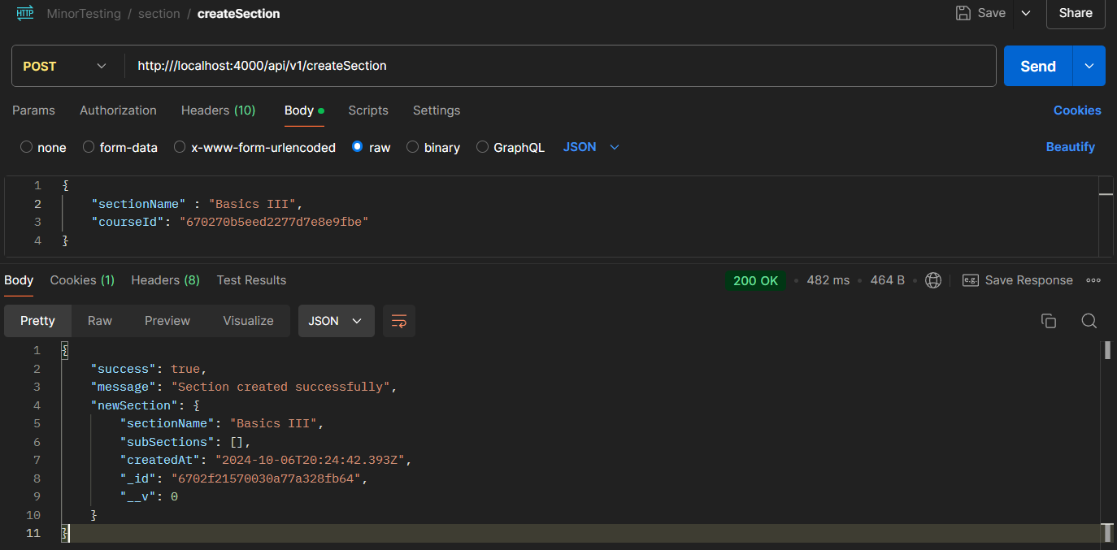

1. editSection:-

API :- http://localhost:4000/api/v1/editSection

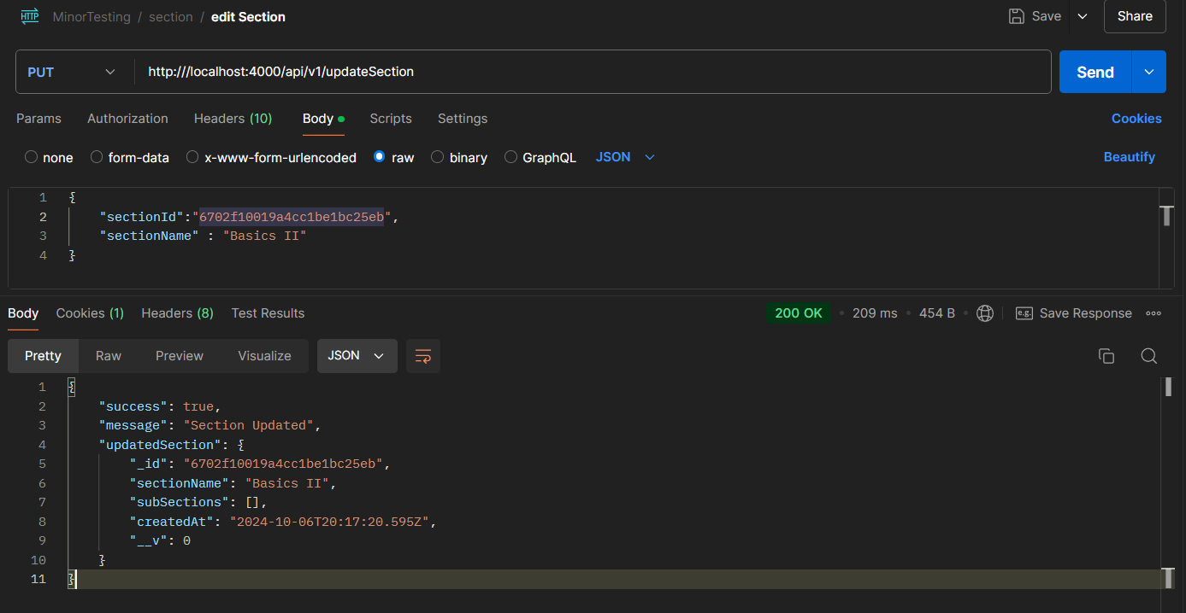

1. deleteSection:-

API :- http://localhost:4000/api/v1/deleteSection

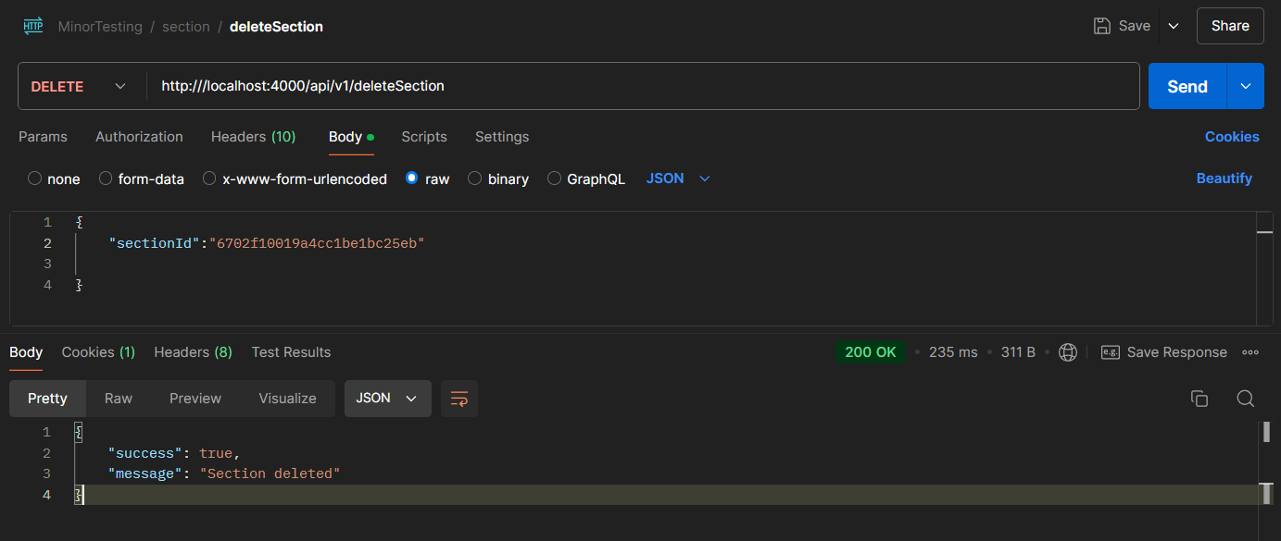

1. createSubSection:-

API :- http://localhost:4000/api/v1/createSubSection

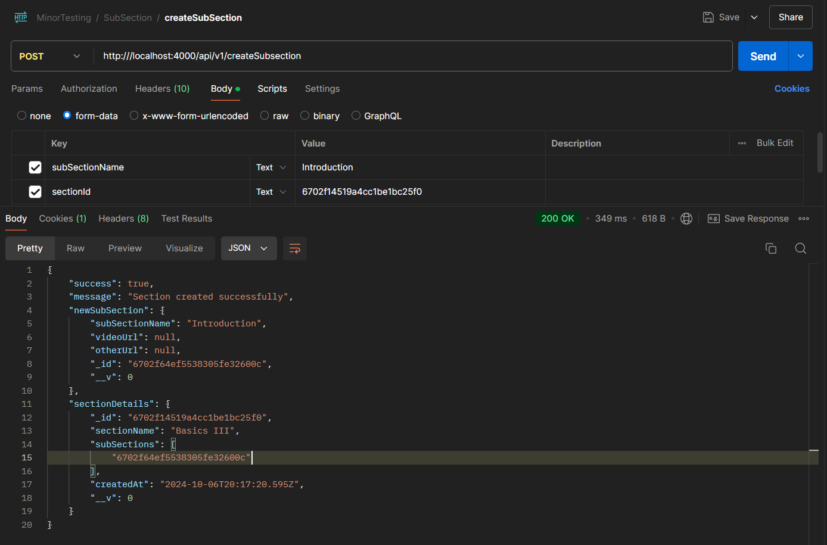

1. editSubSection:-

API :- http://localhost:4000/api/v1/editSubSection

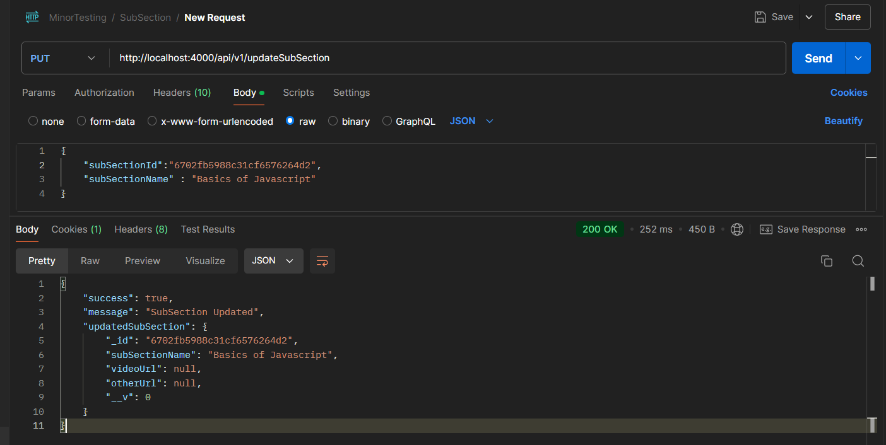

1. deleteSubSection:-

API :- http://localhost:4000/api/v1/deleteSubSection

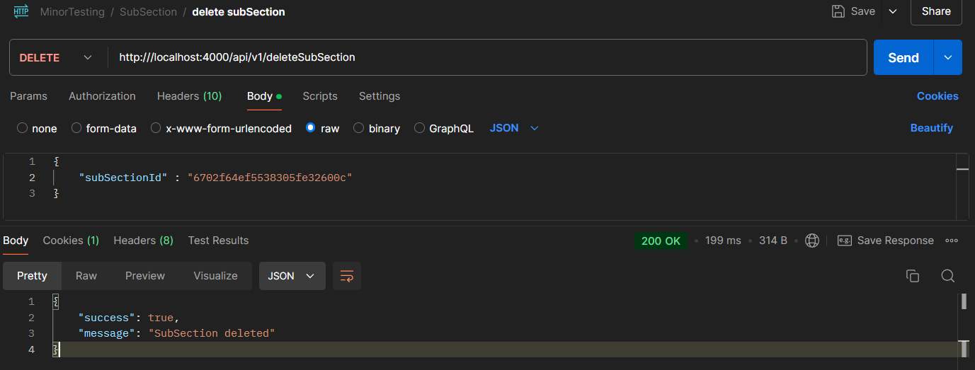

1. assignCourse:-

API :- http://localhost:4000/api/v1/assignCourse

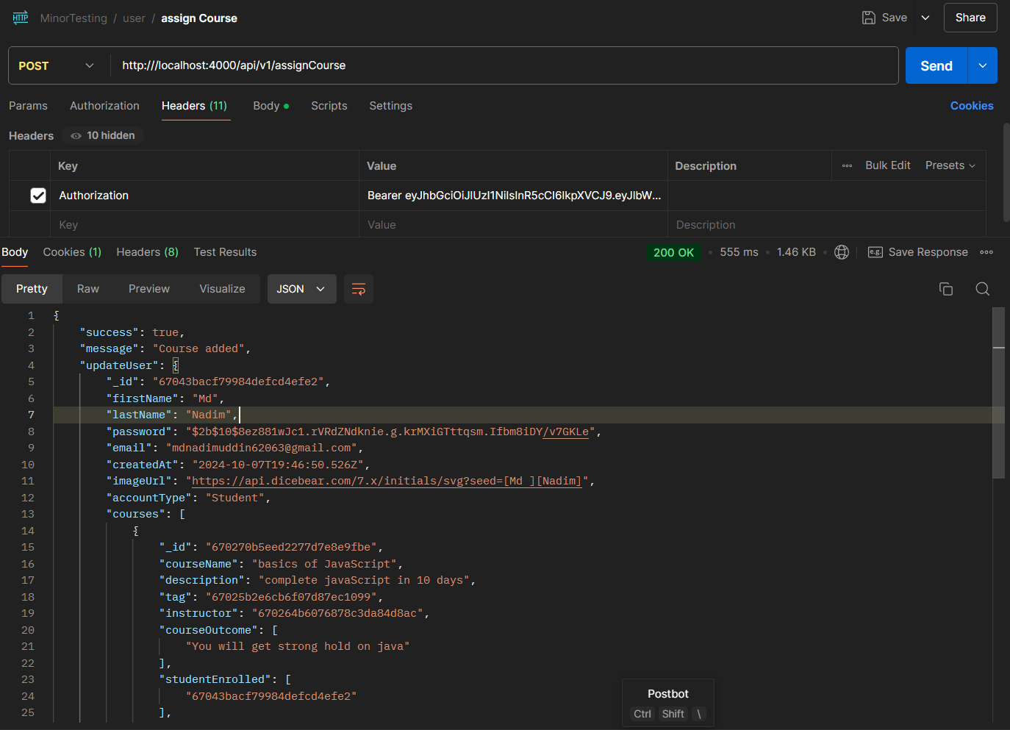

1. getUserDetails:-

API :- http://localhost:4000/api/v1/ getUserDetails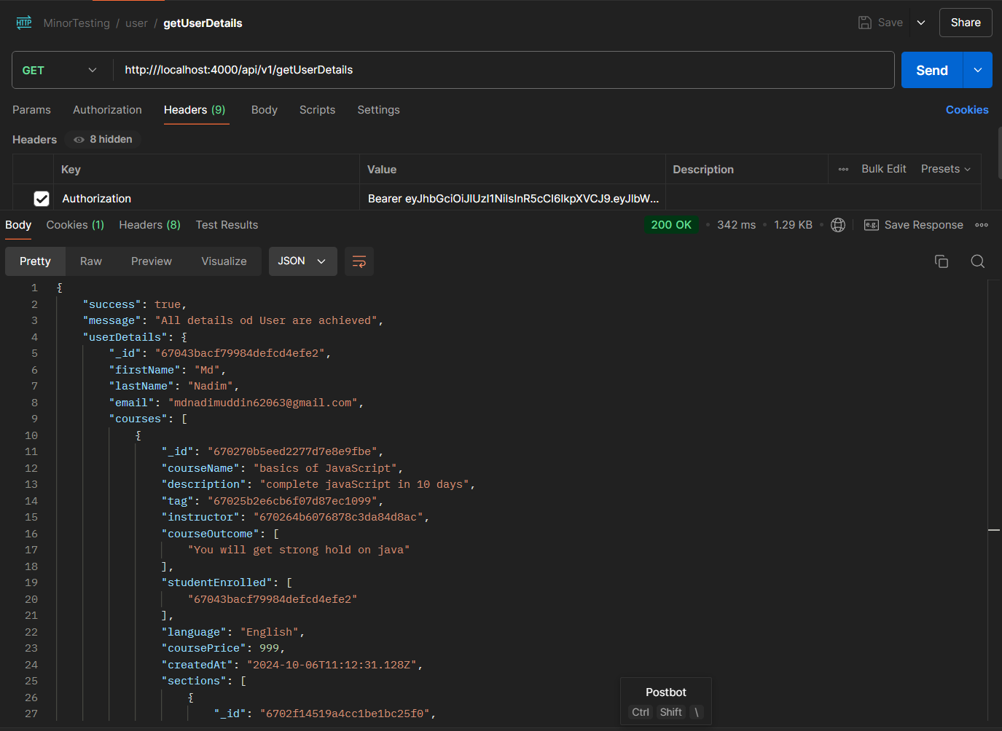

1. createRatingAndReview:-

API :- http://localhost:4000/api/v1/createRatingAndReview

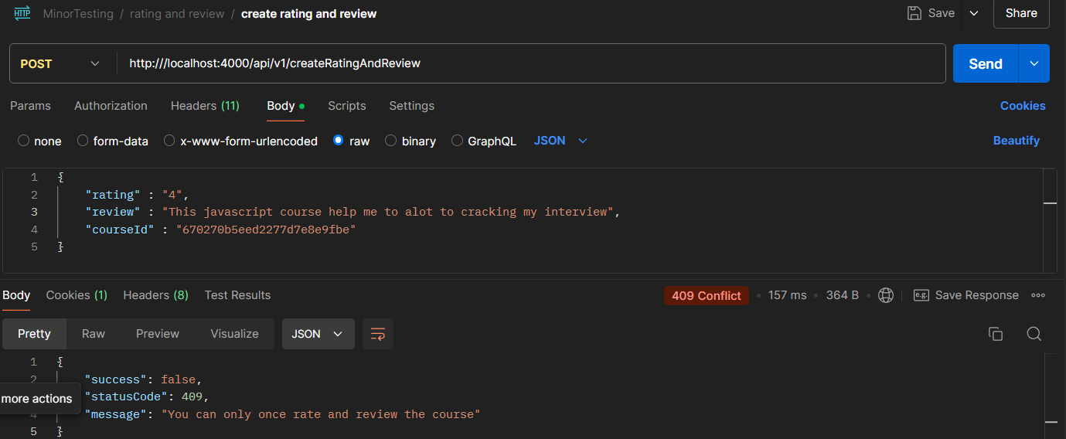

1. editRatingAndReview:-

API :- http://localhost:4000/api/v1/editRatingAndReview

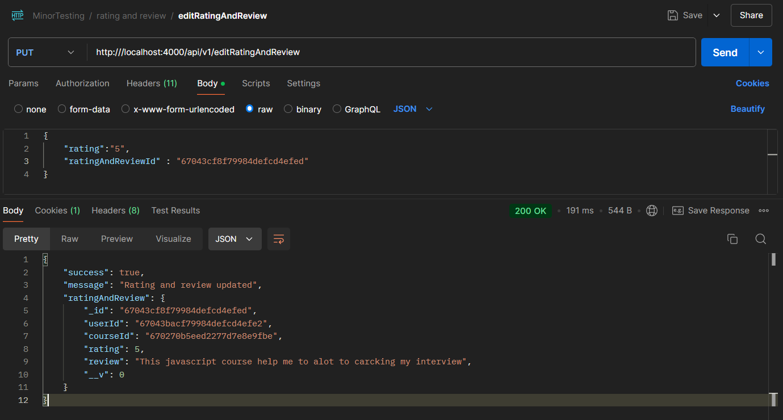

1. getAllRating:-

API :- http://localhost:4000/api/v1/getAllRating

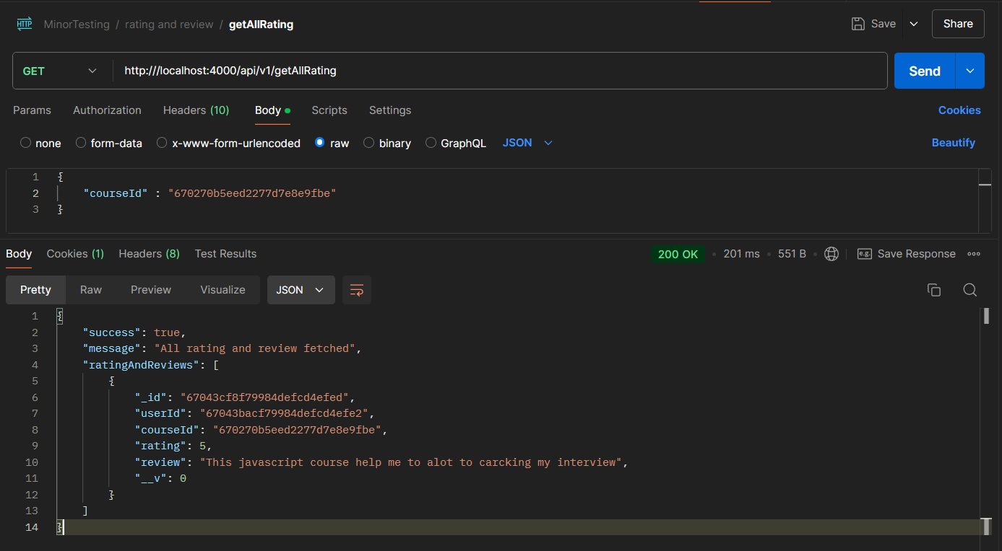

1. deleteRatingAndReview:-

API :- http://localhost:4000/api/v1/ deleteRatingAndReview 